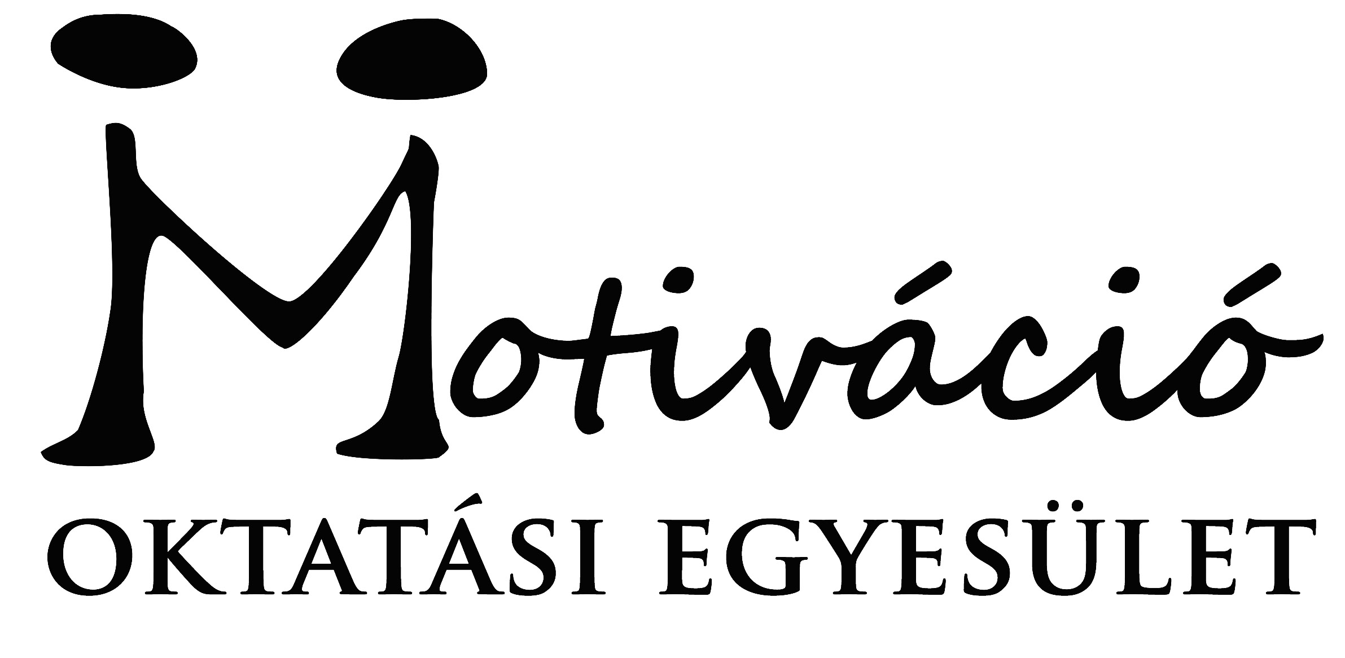
This project is co-funded by the European Union
2017-1-HU01-KA105-035387 project
„Game of T.H.R.O.N.E.S. (Tolerance, Humanity, Reception, Originality, Non-formality, Equality, Sensibility)”

Registration form
Personal Data
The contact details you provide us below will be used for all correspondence!
First Name  [as on your passport] |  |  | Family Name  [as on your passport]
Nationality |  | Date of birth: |  | Gender | Female  Male
Complete address
Postal code |  | Town |  | Country
Phone (preferably mobile)  [with full international dial codes] |  |  | Fax  [with full international dial codes]
Email |  |  | Website
Language(s) abilities: Please mention all languages in which you are able to work and indicate your level for each of it (B-basic, G-good, VG-very good, F-fluent, MT-mother tongue) Anyway we would like to remind you that main working language will be English.
 | Listening | Speaking | Reading | Writing
English
Other languages
[please specify]

Do you have any special needs or requirements that the host organisation should know about? (E.g. mobility, medical needs, allergies, dietary restrictions, smoker/non-smoker)

Please indicate us the name and full contact details of a person to be contacted in case of emergency during the project.
Name
Complete address
Postal code |  | Town |  | Country
Phone  [with full international dial codes] |  |  | Fax  [with full international dial codes]
Email

